Follow-along guide: TikTok Project

This document includes detailed instructions for how to perform the data visualizations shown in the exemplar executive summary.

Part 1: Access Tableau and data
- Go to https://public.tableau.com/s/
- Log in to your account
- Go to My Profile at top right of Tab Public homepage


- Under Vizzes, select Create a Viz
- Upload the dataset: tiktok_dataset.csv

Part 2: Create worksheets
- Click on New Worksheet
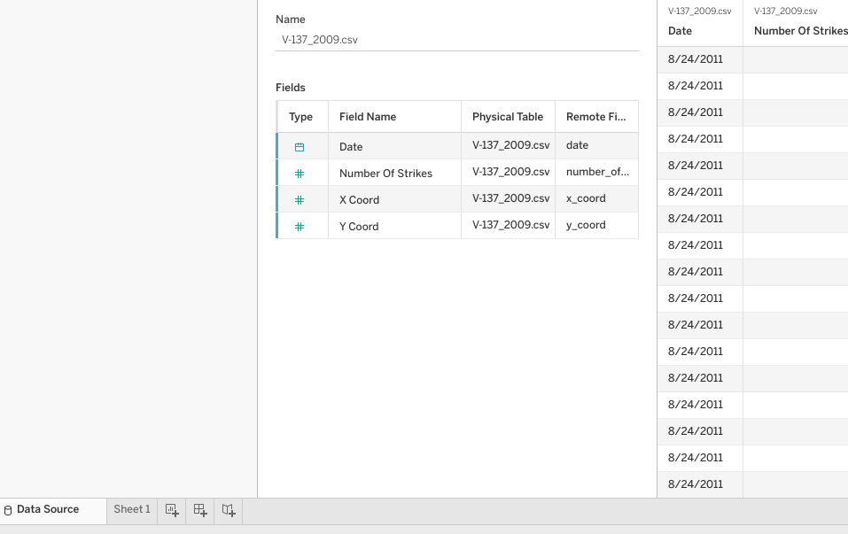

- Drag Video View Count and Video Like Count to the Columns and Rows shelves, respectively
  - Note: Be sure both variables are converted to Dimensions
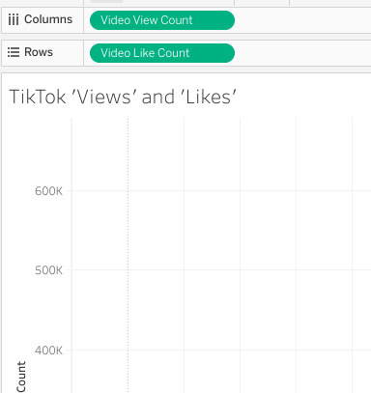

- Drag Claim Status to Color square under the Marks field
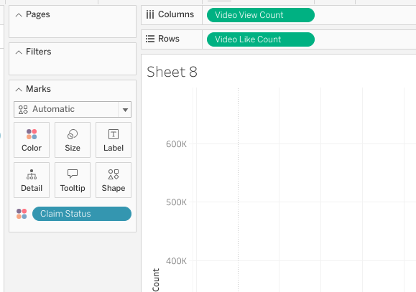
- Use Size in the Marks field to adjust size of scatter plot marks
- Drag Claim Status to Filters field and uncheck the Null box
- Give worksheet a title, like TikTok ‘Views’ and ‘Likes’
- Create a new worksheet
- In Marks dropdown, select Pie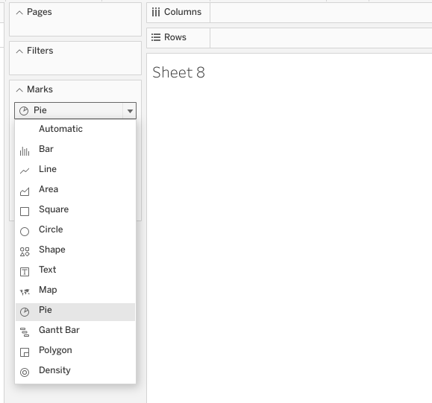
- Drag Claim Status to Color square in the Marks field
- Drag Claim Status to Filters field and uncheck the Null box
- Drag Claim Status to Angle square in the Marks field to set the pie chart
  - Note: Be sure to convert Claim Status variable to Measure > Count
- Drag Claim Status to Label square in the Marks field to show the total count of each
  - Note: Be sure to convert Claim Status variable to Measure > Count
- Drag Claim Status to Label square in the Marks field (This will label the two sides of the pie, “claim” and “opinion”)
- Drag Claim Status to Size square in the Marks field to adjust pie chart size
  - Note: Be sure to convert Claim Status variable to Measure > Count
- Add title to pie chart, like Total Number of Claims versus Opinions
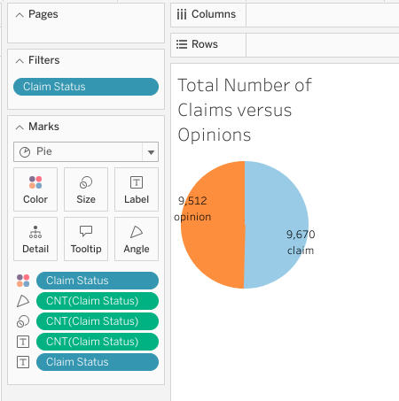
- Create a new worksheet
- Drag Author Ban Status and Video View Count variables to the Columns and Rows shelves, respectively.
- Drag Claim Status to Color square in the Create a new Marks field.
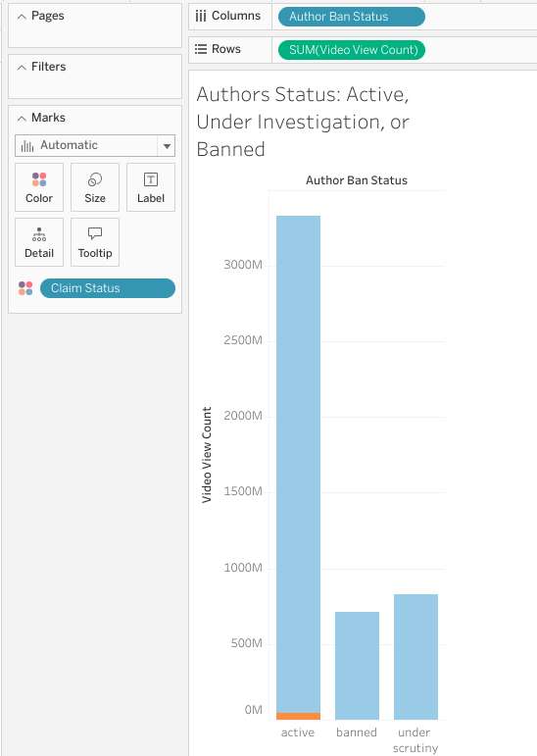
- Give bar chart title like Author Status: Active, Under Investigation, or Banned
- Create a new worksheet
- In Marks field dropdown, select Circle
- Drag Video Like Count to Rows shelf
  - Note: Be sure to select Measure > Count from Video Like Count variable dropdown
- To complete box plot, convert Video Like Count variable to Dimension
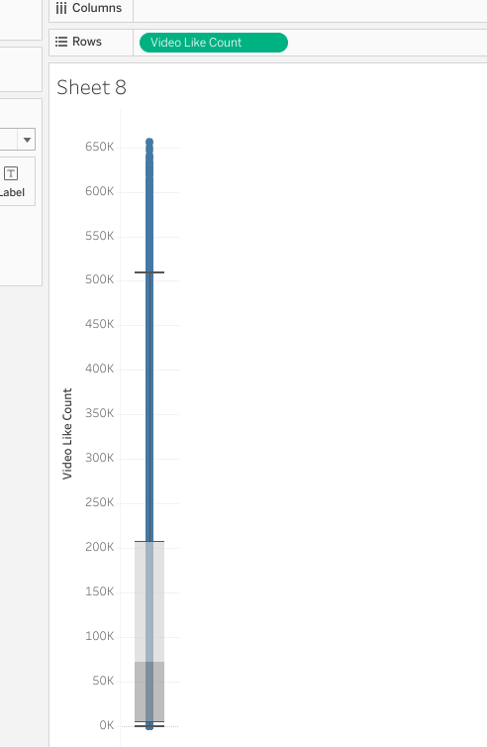
- Create three new worksheets with one boxplot each for Video Comment Count, Video Duration, and Video View Count.
  - Follow same instructions as the boxplot for Video View Count above

Part 3: Create Dashboard and Story
- Click on New Dashboard
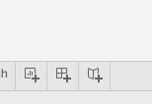

- Notice all worksheets created to this point are in the Sheets field
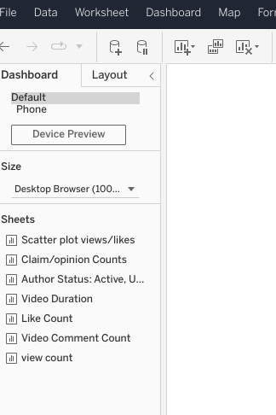

- Drag the scatter plot, pie chart, and bar chart worksheets onto the dashboard and neatly arrange each sheet on the dashboard
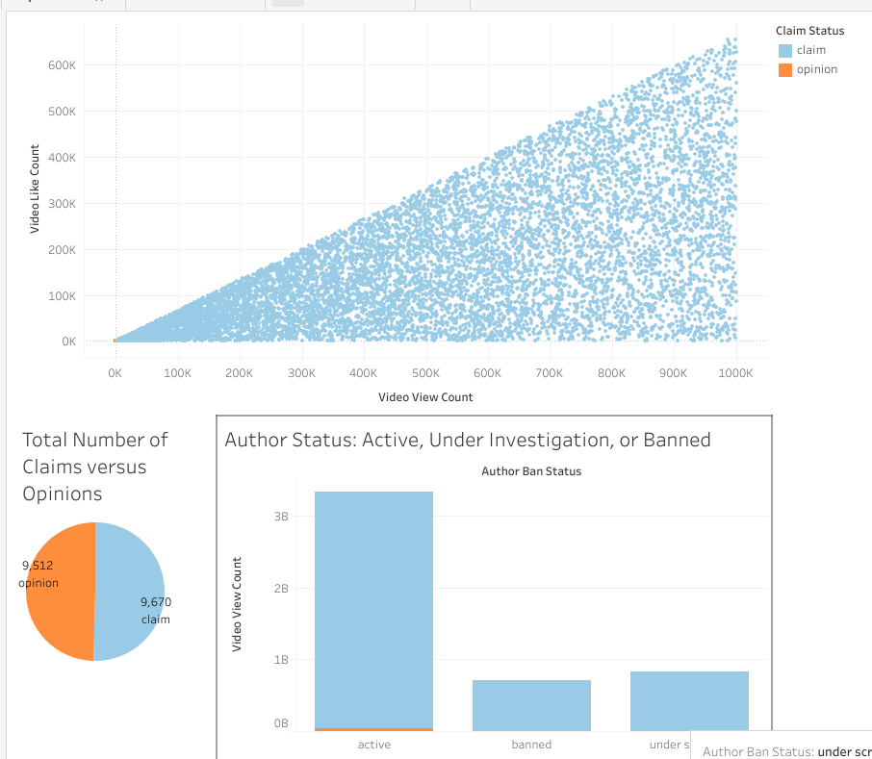
- Click on New Dashboard


- Drag each box plot worksheet onto the dashboard and arrange neatly
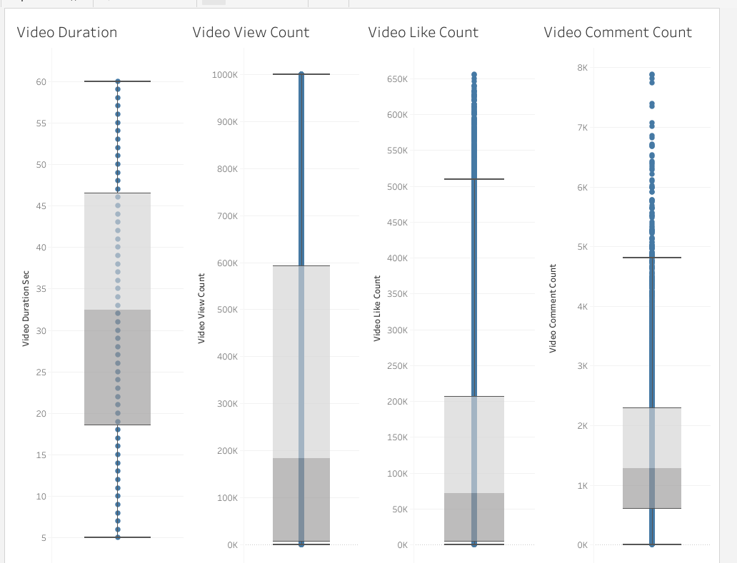
- Adjust titles and legends as needed
- To bring dashboards together, click on New Story
- Notice both dashboards are now listed in the Sheets field
- Drag the dashboard with the scatter plot, pie chart, and bar chart on first page of story
- Add caption and title at the top
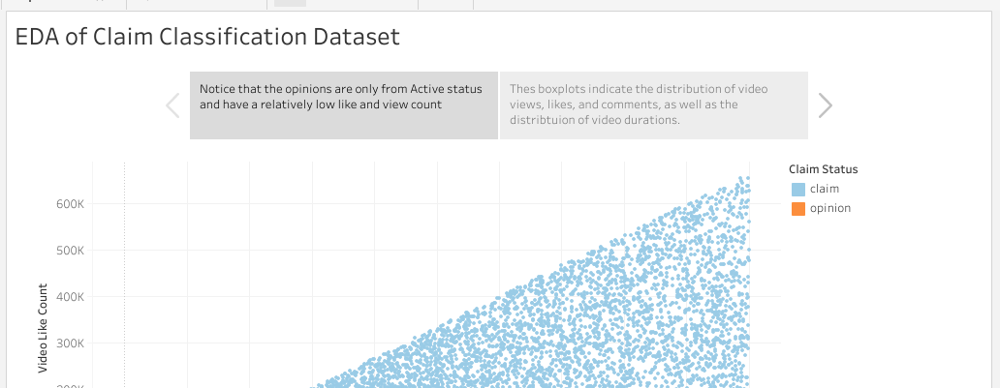
- Navigate to next page of Story
- Drag box plot dashboard to second page of Story
- Add caption and title at top.
